# AskSara User Manual

## Introduction

AskSara is an online tool that helps people find advice and products to support daily living. It’s free, easy to use, and available to everyone in Doncaster.

## Step 1: Accessing AskSara

Go to: [AskSARA for advice, support and products that make daily living easier - City of Doncaster Council](https://www.doncaster.gov.uk/services/adult-social-care/asksara-for-advice-support-and-products-that-make-daily-living-easier)  
No login or account is needed.

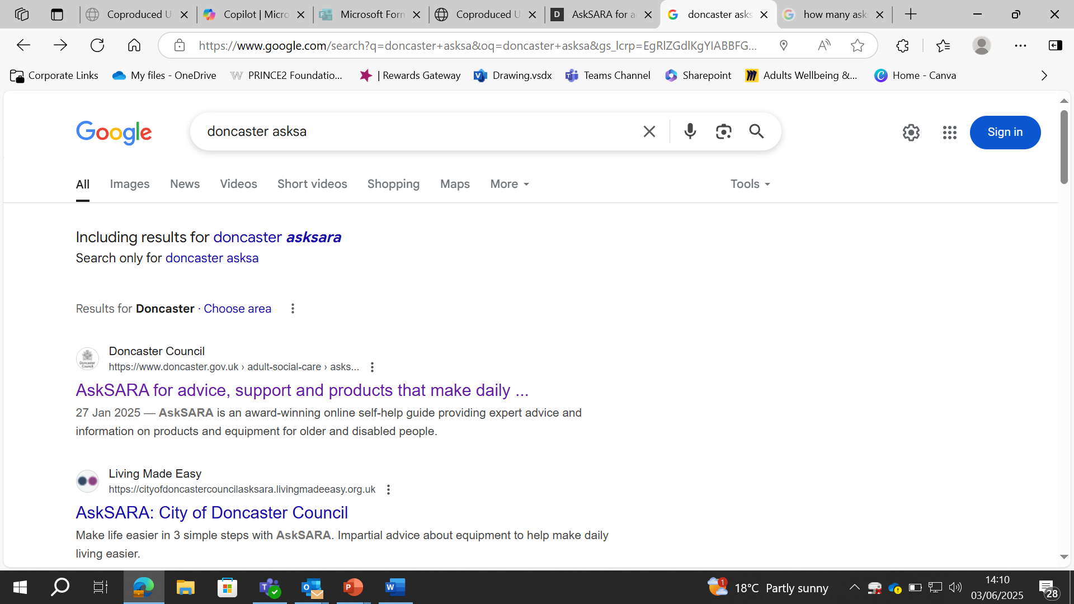

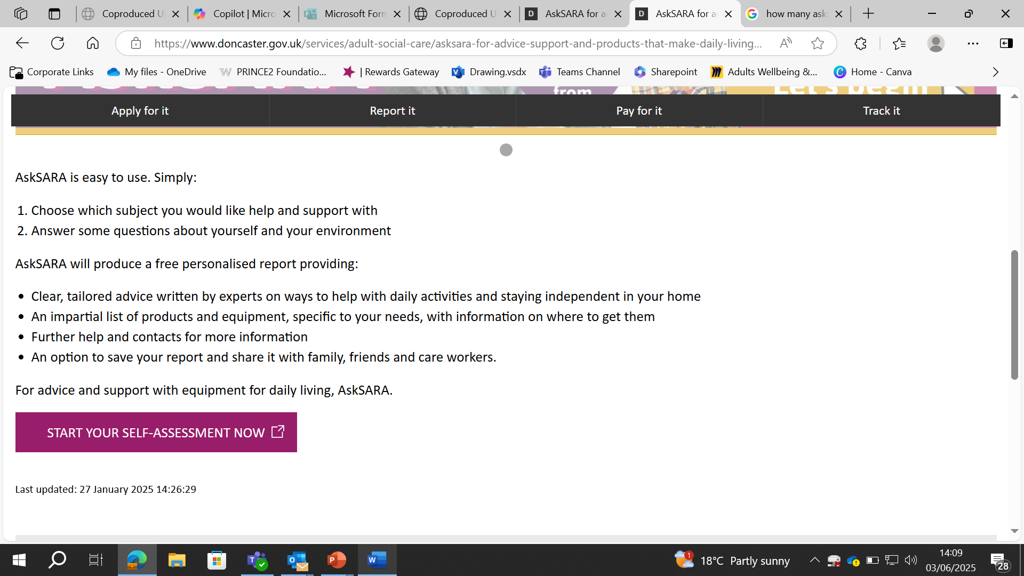

## Step 2: Choosing a Topic

Select a topic that’s relevant to you or someone you support. AskSara has over 90 topics to choose from. Some of the most common are:  
- Mobility  
- Memory  
- Daily routines  
- Mental health

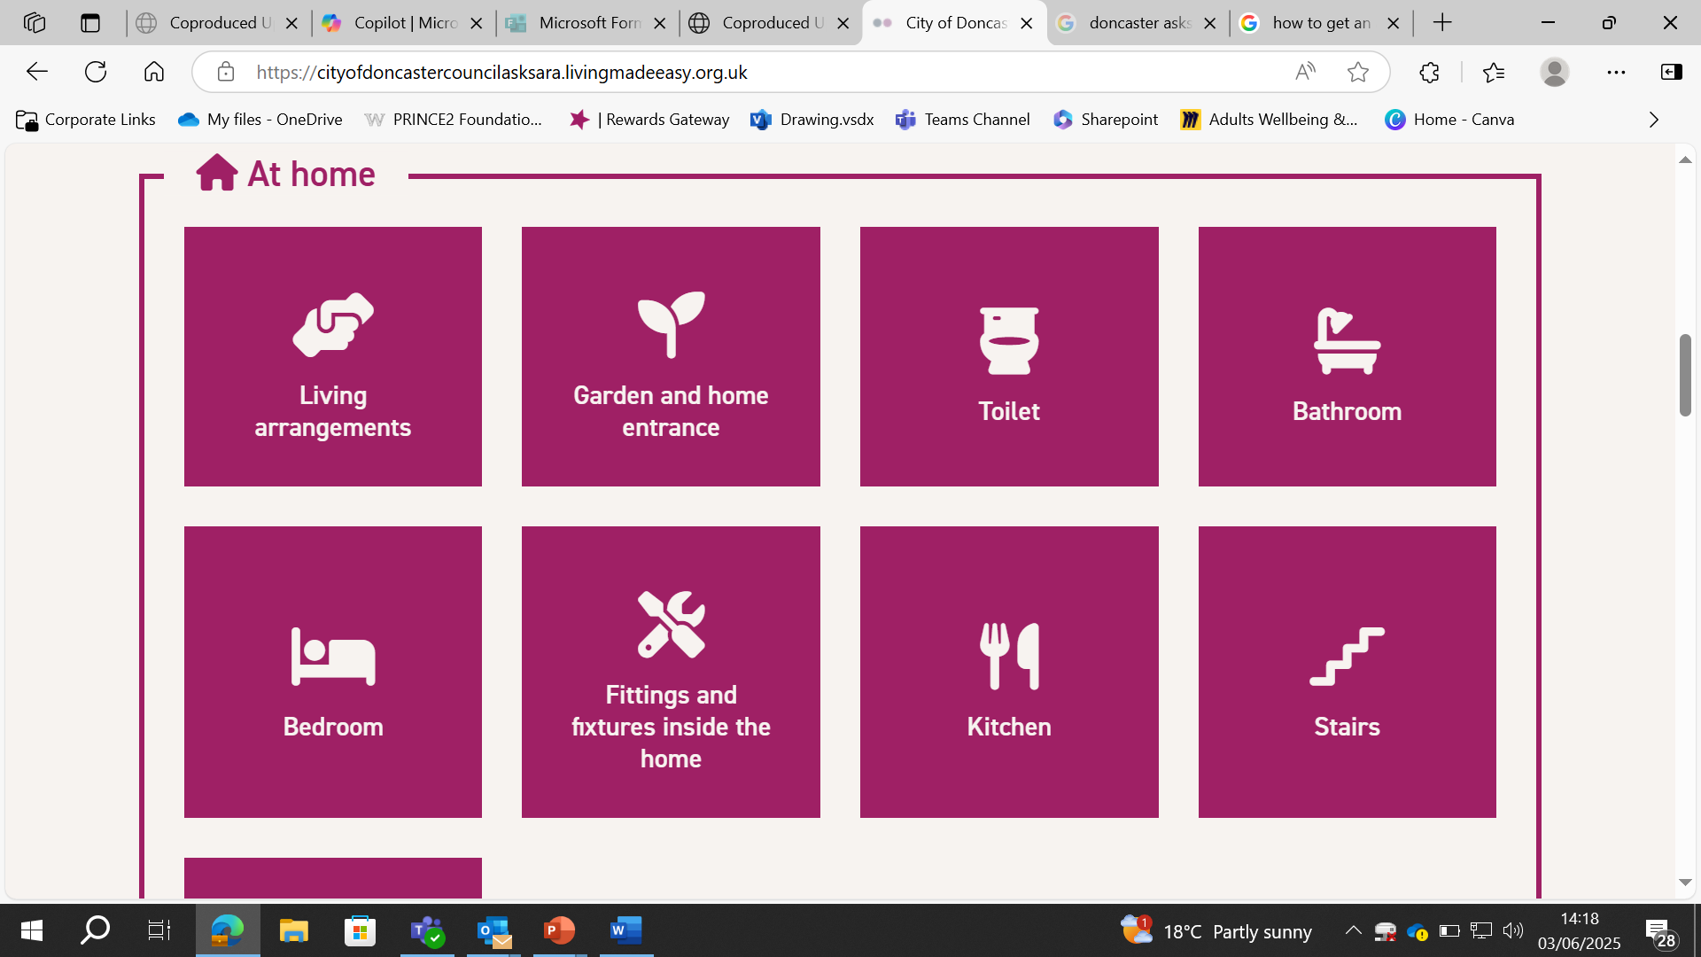

## Step 3: Answering Questions

Answer a few simple questions. This helps AskSara tailor its advice to your needs.

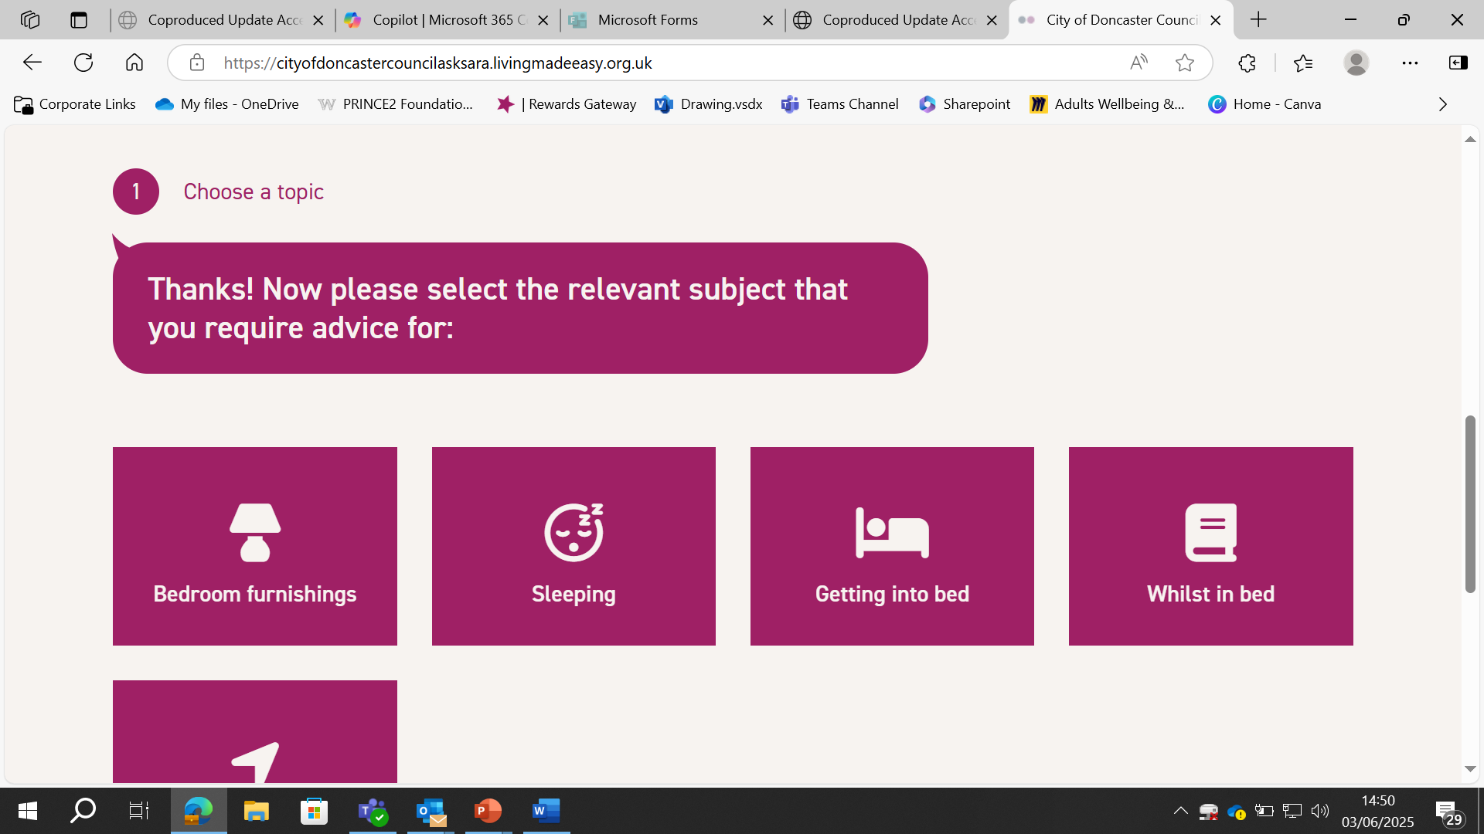

It will then ask a few questions such as:

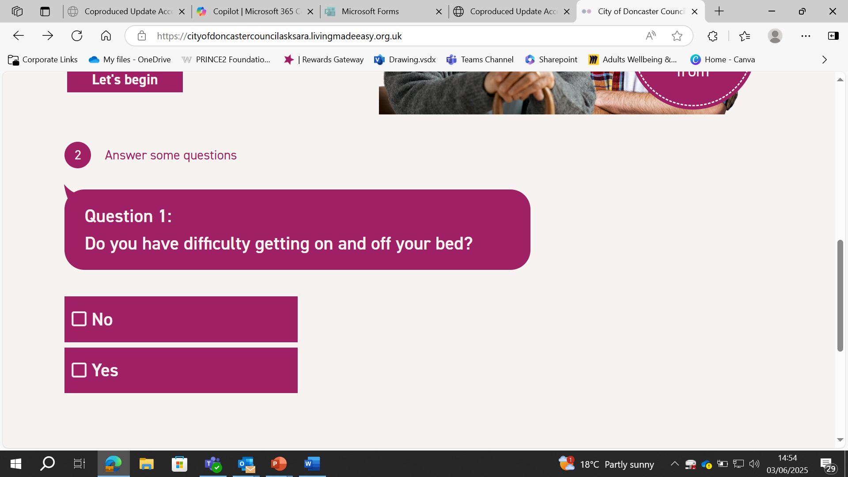

## Step 4: Viewing Your Report

You’ll receive a personalised report with:  
- Practical advice  
- Suggested products  
- Links to suppliers and services

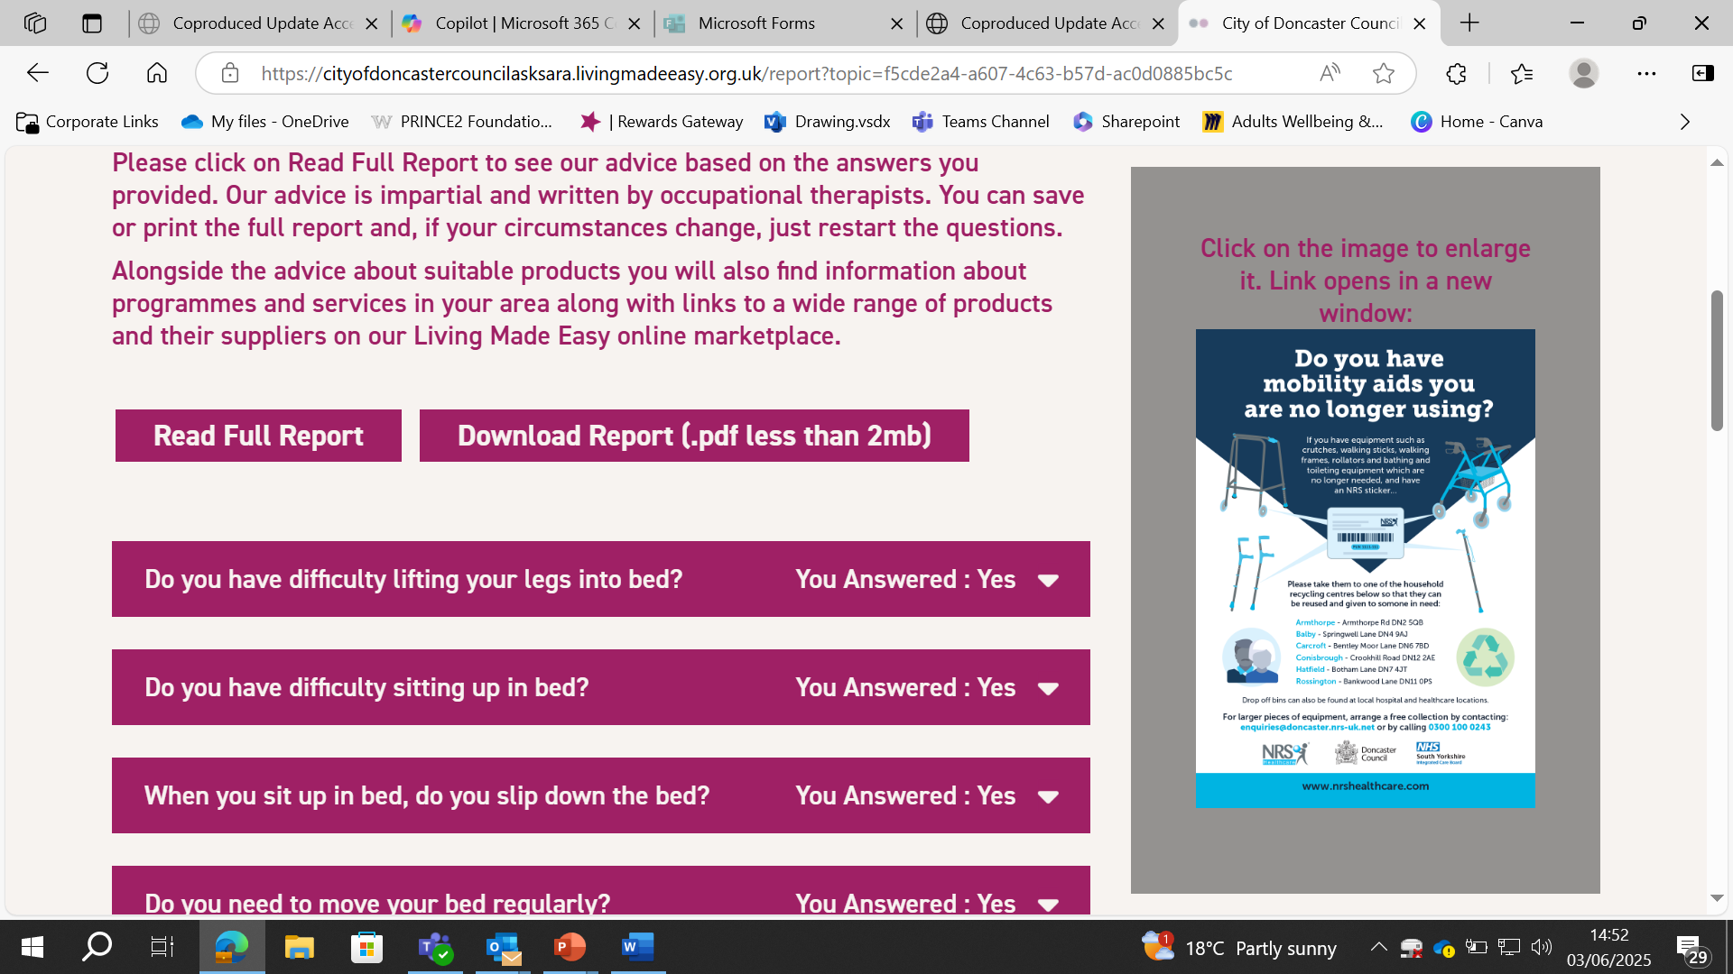

## Conclusion

AskSara is a great starting point for finding support. Share it with colleagues, families, and people you work with.